**DIGITAL LOGIC DESIGN**

**(EL-1005)**

**TRAFFIC CONTROLLER**

**PROJECT REPORT**



Syed Waleed Hussain[23K-0885]

Shayan Naimat [23K-0899]

Muhammad Abdullah [22K-5126]

**Main Objective:**

Our goal is to develop a four-way traffic signal system that efficiently manages intersections, making it safer and easier for vehicles and pedestrians to navigate through busy traffic areas.

**Introduction:**

In this project, we aim to address the challenges of traffic management at intersections by designing and implementing a four-way traffic signal system. The system will utilize electronic components and control mechanisms to regulate the flow of traffic and ensure the safety of both motorists and pedestrians.

**Methodology:**

To build the circuit we had used Bread Board. We had used button to generate clock pulse. We gave ground and voltage by using capacitor and resistor to the button then we connected the clock pulse to the input of 4017 IC in which there are 10 outputs, we connected the outputs of IC with diodes respectively and then connected diodes with LEDs along with resistors to protect LEDs from higher voltage. When each clock pulse will gain by IC, it will open each output and close the previous output. In this way Traffic Controller will work.

The traffic signal system responds to the activation of the button, triggering the sequential change in the traffic lights' status. This manual control mechanism ensures flexibility and adaptability to different traffic conditions and user preferences.

**Costing (In a proper Tabular Format):**

Resistors:

1KΩ: 5 per piece

10KΩ: 5 per piece

220Ω: 5 per piece

Capacitors:

10µF: 15per piece

100µF: 20 per piece

LEDs:

RED: 5 per piece

BLUE: 5 per piece

YELLOW: 5 per piece

CD4017 Decade Counter IC: 150 per piece

IN4007 Diodes: 10 per piece

Button (Switch): 15 per piece

**Circuit Diagram:**

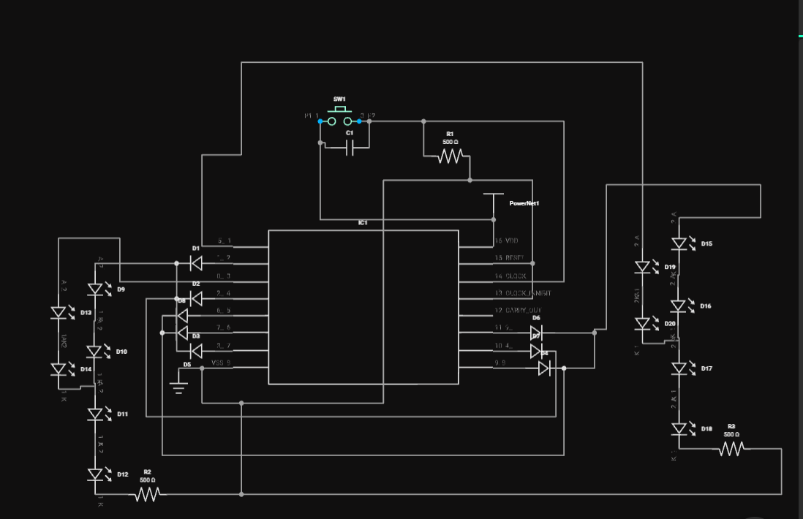

**Application:**

In this project, “Traffic Controller”, we had used cd4017 IC. It allows to on output one by one and it off the previous output after getting each clock pulse from button. We had used button which allows to create clock pulse. We had used jumper wires for connection, resistors to control current amount, capacitor to block direct current while allowing alternating current to pass, diodes to keep current to ensure that current flows in the correct direction, allowing for proper sequencing and control of the traffic lights.

The developed four-way traffic signal system can be implemented at intersections in urban areas, highways, and other locations with heavy traffic volume. Its efficient operation and low-cost components make it suitable for widespread adoption to improve traffic management and safety.

**Conclusion:**

The development of a four-way traffic signal system offers a practical solution to the challenges of traffic management at intersections. By utilizing simple electronic components and an effective manual control mechanism, the system can significantly enhance safety and efficiency in urban transportation networks.

------------------------------------------------------------------------------